**SECTION A**

**SUB SECTION I**

**Questions 1 to 50 carry one mark each.**

**In questions 1 to 5, fill in the blank spaces with a suitable word.**

1. The bus arrived ………………………… the school compound before it started raining.

2. In ……………………………………… class is your elder brother now?

3. What a big mistake the cyclist has ………………………………………………!

4. I shall attend remedial ………………………………………. during holidays.

5. The police ……………………………………………going to arrest all the suspects today.

**In questions 6 to 15, use the correct form of the word given in brackets to complete the sentence.**

6. It is good for candidates to follow …………………………………….. carefully. (instruct)

7. Every ………………………………………………must respect the Highway Code. (motor)

8. Young children always like ……………………………… kites during windy weather. (fly)

9. Jethro had to wait ………………………………………… until the doctor came. (patient)

10. The priest will baptize all those …………………………………………next Sunday. (baby)

11. Moro Ernest is the ……………………………………………. of the twin sisters. (thin)

12. Our school choir has ………………………… the best song at the music festival. (sing)

13. We read the …………………………… that appeared in the Nile Newspaper yesterday. (advertise)

14. Nathan and Benjamin usually pray for ….………………… to have peace. (they)

15. She supported the ……………………………………side in the class debate. (oppose)

**In questions 16 and 17, use each of the given words in a sentence to show that you know the difference in their meaning.**

16. dump

……………………………………………………………………………………………………………………………………………………………………………………………………………………………………

17. damp

……………………………………………………………………………………………………………………………………………………………………………………………………………………………………

**In questions 18 to 20, rewrite the sentence giving a single word for the underlined group of words.**

18. The conference hall is next to the swimming pool.

……………………………………………………………………………………………………………………………………………………………………………………………………………………………………

19. He will give information about what he saw to police tomorrow.

……………………………………………………………………………………………………………………………………………………………………………………………………………………………………

20. Many people in our sub county earn a living from catching fish.

……………………………………………………………………………………………………………………………………………………………………………………………………………………………………

**In questions 21 and 22, write the given abbreviations in their full forms.**

21. Rev. ……………………………………………………………………………………………

22. Cert. .……………………..………….………………………………………………………

**In questions 23 and 24, rearrange the jumbled words to form a meaningful sentence.**

23. believers to good God for It is offer to.

……………………………………………………………………………………………………………………………………………………………………………………………………………………………………

24. to the What direction butcher’s is the?

……………………………………………………………………………………………………………………………………………………………………………………………………………………………………

**In questions 25 and 26, rewrite giving the opposite of the underlined word.**

25. It is very healthy to share a house with animals.

……………………………………………………………………………………………………………………………………………………………………………………………………………………………………

26. My stepmother has bought a new phone.

……………………………………………………………………………………………………………………………………………………………………………………………………………………………………

**In questions 27 and 28, give the plural form of the given word.**

27. garment …………………………………………………….............

28. banana leaf …………………………………………………………………

**In questions 29 and 30, rearrange the words in alphabetical order.**

29. before, down, across, close

………………………………………………………………………………………………………………………………………………………………………………………………………………………………

30. burial, blessing, baptism, bottle

………………………………………………………………………………………………………………………………………………………………………………………………………………………………

**In questions 31 to 50, rewrite as instructed in brackets.**

31. It is bad for children to disobey elders in their community. (Rewrite the sentence using: ………….should not …………)

………………………………………………………………………………………………………………………………………………………………………………………………………………………………

32. Do you like reading the Bible more than reading story books? (Rewrite the sentence using: …………prefer……….)

………………………………………………………………………………………………………………………………………………………………………………………………………………………………

33. Mr. Iguru repairs vehicles cheaply. I told you about him yesterday. (Join the two sentences using: ……….about whom ………)

………………………………………………………………………………………………………….…………………………………………………………………………………………………………………….

34. If Elizabeth keeps time, she will board the first bus to Kenya.

(Rewrite the sentence using: …………would board ……….)

………………………………………………………………………………………………………………………………………………………………………………………………………………………………

35. The school nurse has treated the sick pupils. (Rewrite the sentence ending:……………by the school nurse.)

………………………………………………………………………………………………………………………………………………………………………………………………………………………………

36. What is the shape of a gun? (Rewrite the sentence beginning: What does a gun………….?)

………………………………………………………………………………………………………………………………………………………………………………………………………………………………

37. Immediately Lambet saw a mosquito on his hand, he killed it. (Rewrite the sentence using: …………as soon as………….)

………………………………………………………………………………………………………………………………………………………………………………………………………………………………

38. We shall share the fruit during lunch time. (Rewrite the sentence ending:…………….having lunch.)

……………………………………………………………………………………………………………………………………………………………………………………………………………………………..

39. Although the policeman stopped the taxi, it was not necessary. (Rewrite the sentence using: …………needn’t have …………)

………………………………………………………………………………………………………………………………………………………………………………………………………………………………

40. This sandpaper is very old. It cannot smooth the furniture.

(Join the two sentences using: …………too ………to……….)

………………………………………………………………………………………………………………………………………………………………………………………………………………………………

41. Bruno mixed the ingredients. He also kneaded the dough. (Rewrite as one sentence beginning: Besides ………..)

………………………………………………………………………………………………………………………………………………………………………………………………………………………………

42. My uncle burnt the rubbish. He first collected it. (Join the sentences using:………..before ………)

………………………………………………………………………………………………………………………………..…………………………………………………………………………………………….

43. Otera has an index number. Nakato also has an index number.

(Rewrite as one sentence using: Both …………….)

………………………………………………………………………………………………………………………………….…………………………………………………………………………………………..

44. He withdrew some money from his bank account, didn’t he? (Rewrite the sentence ending: ………., did he?)

………………………………………………………………………………………………………………………………………………………………………………………………………………………………

45. The English lesson in primary seven started just now.

(Rewrite the sentence using: ………….already ………….)

………………………………………………………………………………………………………………………………………………………………………………………………………………………………

46. Look up the new words. Borrow a dictionary. Go to the library. (Rewrite as one sentence using; First ………next ………..then ……..)

………………………………………………………………………………………………………………………………………………………………………………………………………………………………

47. The tailor did not sew my uniform properly. She used a tape measure. (Join the sentences beginning: In spite ……….)

………………………………………………………………………………………………………………………………………………………………………………………………………………………………

48. “Our candidates are going to break up for holidays tomorrow,” said the teachers. (Rewrite the sentence using: …………said that ………)

………………………………………………………………………………………………………………………………………………………………………………………………………………………………

49. Emwodu has built a circular house. It is small. It is a beautiful house. (Rewrite as one sentence without using: “which, “and” or “that)

………………………………………………………………………………………………………………………………………………………………………………………………………………………………

50. Werikhe often wears a helmet before riding his motorcycle. (Rewrite the

sentence using: ……………sometimes ………..)

………………………………………………………………………………………………………………………………………………………………………………………………………………………………

**SECTION B**

**(5 QUESTIONS 10 MARKS EACH)**

51.**Read this passage and use it to answer the questions that follow.**

Natale is a twelve–year–old primary six girl. She is in Mamba Primary School. Natale is a bright girl. She comes from a family of rich people.

When Natale was in primary four, she didn’t want to **take part** in cleaning activities at school. She was quite proud of herself. She underlooked all her friends. She always called them poor, foolish and useless. Natale said cleaning should be done by other pupils. Even during lessons, Natale couldn’t share a desk with any pupil. She despised all of them. Because of her behavior, Natale didn’t have any friends.

One day, Natale fell ill at school. This happened in the dormitory. All teachers had already gone to their homes. All the girls refused to call the school nurse to come and help Natale. “Let’s leave her to suffer since she calls us useless,” Badaru Liza, one of the girls, suggested. Natale cried in pain for her friends’ help.

A girl called Namale Samantha had another idea. She politely said to her friends, “It is not good to pay evil for evil. Let’s not revenge ourselves on her. Natale deserves to be forgiven because we are all God’s children. Let’s be good to her so that she can change.” Namale’s words were respected by most girls. They eventually carried Natale to the sick bay. The school nurse thanked them for being caring. She treated Natale.

The following day, Natale got better. She was **grateful** to all the girls for taking her to the sickbay for treatment. She humbly apologized to them for being badly– behaved. “I am so sorry for my misbehavior. I shall share my property and eats with all of you,” she said to them. Since that day, Natale is the most disciplined pupil in the school.

1. How old is Natale?

………………………………………………………………………………………………………………………………………………………………………………………………………………………………

b) When didn’t Natale take part in cleaning?

………………………………………………………………………………………………………………………………………………………………………………………………………………………………

c) Why didn’t other pupils want to be Natale’s friends?

………………………………………………………………………………………………………………………………………………………………………………………………………………………………

d) Where did Natale fall ill?

………………………………………………………………………………………………………………………………………….…………………………………………………………………………………

e) What did Badaru Liza suggest to the friends?

……………………………………………………………………………………………………………………………………..…………………………………………………………..…………………………

f) Who discouraged the friends from paying evil for evil?

……………………………………………………………………………………………………………………………………………………………………………………………………………………………

g) How did the girls help Natale?

………………………………………………………………………………………………………………………………………..…………………………………………………………………………………

h) Give one word or group of words with the same meaning as the words underlined in the passage.

(i) take part

………………………………………………………………………………………………….………

(ii) grateful

………………………………………………………………………………………………………….

1. Suggest a suitable title to the passage.

…………………………………………………………………………………………………………………………………………………………………………………………………..…………………………

52. **The table below shows farm activities. They were done in 2024. This was in the school garden. The garden was for Mpererwe C/U Primary School. Study it carefully and use it to answer the questions that follow in full sentences.**

|  |  |  |  |  |  |  |
| --- | --- | --- | --- | --- | --- | --- |
| **S/**  **no.** | **Farm activity** | **class** | **Gender** | **Teacher in charge** | **Appreciation to each pupil** | **Time** |
| 1. | tree planting | P7 | B | Mrs. Andama  Violet | a tree seedling | 7:00a.m.-  8:15a.m. |
| 2. | weeding maize plants | P4 | B | Miss. Zahara kadama | a bun for breakfast | 9:30a.m.-  10:30a.m. |
| 3. | spraying tomato plants | P3 | B | Mr. Nyombi  Tadeo | sugarcane | 7:40a.m.-  8:00a.m. |
| 4. | watering cabbages in the nursery bed | P5 | G | Mr. Latuk  Samuel | a bottle of water | 8:20a.m.-  8:45a.m. |
| 5. | harvesting beans | P6 | G | Mrs. Masaba  Christine | a mug of fresh beans | 9:00a.m.-  11:45a.m. |
| 6. | planting groundnuts | P7 | G | Miss. Engola  Brenda | a tree seedling | 10:15a.m.-  11:30a.m. |
| 7. | thinning of maize plants | P4 | G | Miss. Zahara  Kadama | a bun for breakfast | 10:30a.m.-  10:45a.m. |
| 8. | mulching the tomato garden | P3 | G | Mrs. Andama  Violet | sugarcane | 11:00a.m.-  11:50a.m. |
| 9. | collecting cow dung from the school cattle farm | P6 | B | Mr. Ghanghiliba David | a cup of milk | 7:30a.m-  9:30a.m. |
| 10. | fencing the maize garden | P5 | B | Mr. Odeke  Wilberforce | a bottle of water | 9:45a.m.-  10:00a.m. |

**KEY: P – Primary B – boys G – girls**

a) In which school were the above farm activities carried out?

…………………………………………………………………………………………………………………………………………….………………………………………………………………………………

b) Where did the primary five girls water the cabbages from?

………………………………………………………………………………………………………………………………………………………………………………………………………………………………

c) What happened to the tomato plants that day?

…………………………………………………………………………………………………………………………………………..…………………………………………………………………………………

d) At what time of the day did the pupils do the farm activities?

………………………………………………………………………………………………………………………………………………………………………………………………………………………………

e) Who supervised the collection of cow dung from the cattle farm?

……………………………………………………………………………………………………………………………………………………………………………………………………………………………

f) What was the last activity done by the pupils that day?

………………………………………………………………………………………………………………………………………………………………………………………………………………………………

g) Which class harvested beans from the school garden?

…………………………………………………………………………………………………………………………………………..…………………………………………………………………………………

h) How many teachers participated in the supervision of the learners?

………………………………………………………………………………………………………………………………………….…………………………………………………………………………………

i) When did the P4 boys weed the maize plants?

………………………………………………………………………………………………………………………………………………………………………………………………………………………………

j) How did the teachers thank the P7 pupils after gardening?

………………………………………………………………………………………………………………………………………………………………………………………………………………………………

**53. Read this poem and use it to answer the questions that follow in full sentences.**

Safety on the road is our concern Traffic dangers daily

Our lives are not safe

The right of way we need

But politicians can’t allow us

Dear **motorists**! Know this!

The roots of tomorrow we are! Though we walk to school daily We are not criminals

At the zebra crossing

You ought to respect us

Afande Traffic Officer,

Please be there to protect us Arrest those reckless motorists Those regular offenders

Of the Highway Code

For our lives to be safe

Our parents, we fear those riders

They never mind about life

Not even their own Helmets they don’t wear For us to remain safe,

Don’t allow them to carry us!

a) Which right does the writer need on the road?

……………………………………………………………………………………………………………………………………………………………………………………………………………………………………

b) Who doesn’t allow the writer to get that right of way?

……………………………………………………………………………………………………………………………………………………………………………………………………………………………………

c) Who is speaking in the poem?

……………………………………………………………………………………………………………………………………………………………………………………………………………………………………

d) Where must motorists show respect to the writer and her friends?

……………………………………………………………………………………………………………………………………………………………………………………………………………………………………

e) How should traffic officers protect the writer and other road users?

……………………………………………………………………………………………………………………………………………………………………………………………………………………………………

f) What do the motorists disobey according to the poem?

……………………………………………………………………………………………………………………………………………………………………………………………………………………………………

g) Why do you think the writer fears riders?

……………………………………………………………………………………………………………………………………………………………………………………………………………………………………

h) How many stanzas do you see in the poem?

………………………………………………………………………………………………………………….………………..…………………………………………………………………………………………………

i) Give another word or group of words with the same meaning as the words underlined in the poem.

i) motorist ……………………………………………………………………

ii) reckless …………………………………………………………………..

***54. The sentences below are in an incorrect order. Rearrange them carefully to make a short composition about. “The importance of a reading culture in a school”.***

a) Such skills include abstinence from sex.

b) Pupils learn more about security, sports and health tips.

c) Most of the boys and girls have improved their personal hygiene.

d) When they abstain from sex, they are able to live long finally.

e) These teachers mostly use newspapers to promote it.

f) Reading is a culture in all classes at our school.

g) In addition, they have acquired life skills.

h) The newspapers teach the pupils a lot of things.

i) Those health tips are useful for both boys and girls.

j) This culture is developed among the pupils by teachers.

………………………………………………………………………………………………………………………………………………………………………………………………………………………………………………………………………………………………………………………………………………………………………………………………………………………………………………………………………………………………………………………………………………………….…………………………………………………………………………………………………………………………………………………………………………………………………………………………………………………………………………………………………………………………………………………………………………………………………………………………………………………………………………………………………………………………………………………………………………………………………………………………………………………………………………………………………………………………………………………………………………………………………………………………………………………………………………………………………………………………………………………………………………………………………………………………………………………………………………………………………………………………………………………………………………………………………………………………………………………………………………………………………………………………………………………………………………………………………………………………………………………………………………………………………..........................................................................................................................................................................................................

**55. The pictures A to F tell a story. In one sentence, describe what is happening in each picture. You may use these words to guide you.**

breaking up, celebrate, pray, examination, reverend, invigilator, discuss, bless, candidates, groups, check, finish doing, come out

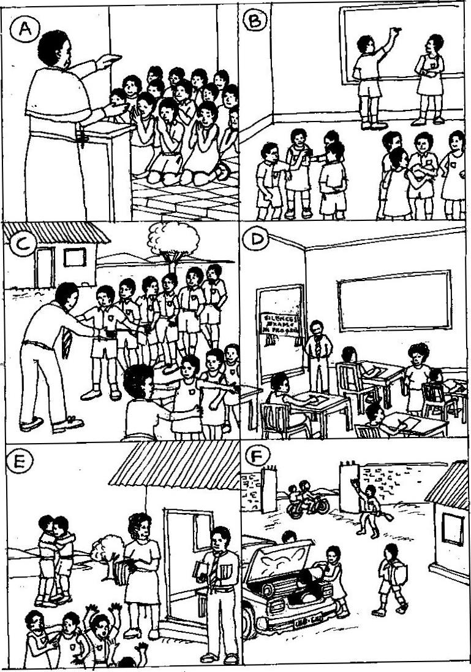

a) Picture A: ………………………………………………………………………………………………….

……………………………………………………………………………………………………………………

b) Picture B; ………………………………………………………………………………………………….

……………………………………………………………………………………………………………………

c) Picture C: ………………………………………………………………………………………………….

……………………………………………………………………………………………………………………

d) Picture D: ………………………………………………………………………………………………….

……………………………………………………………………………………………………………………

e) Picture E: ………………………………………………………………………………………………….

……………………………………………………………………………………………………………………

f) Picture F ………………………………………………………………………………………………….

……………………………………………………………………………………………………………………

g) Who are the people watching over the candidates in picture D?

……………………………………………………………………………………………………………………………………………………………………………………………………………………………………

h) In picture B, why should the candidates discuss in groups?

……………………………………………………………………………………………………………………………………………………………………………………………………………………………………

i) What shows that the candidates in the picture study in a God-fearing school?

……………………………………………………………………………………………………….……………………………………………………………………………………………………………………………

j) Suggest a suitable title to the picture story.

……………………………………………………………………………………………………………………………………………………………………………………………………………………………………

**END**

**“May the Almighty God bless you”**